CS 255 System Design Document Template

UML Diagrams

UML Use Case Diagram
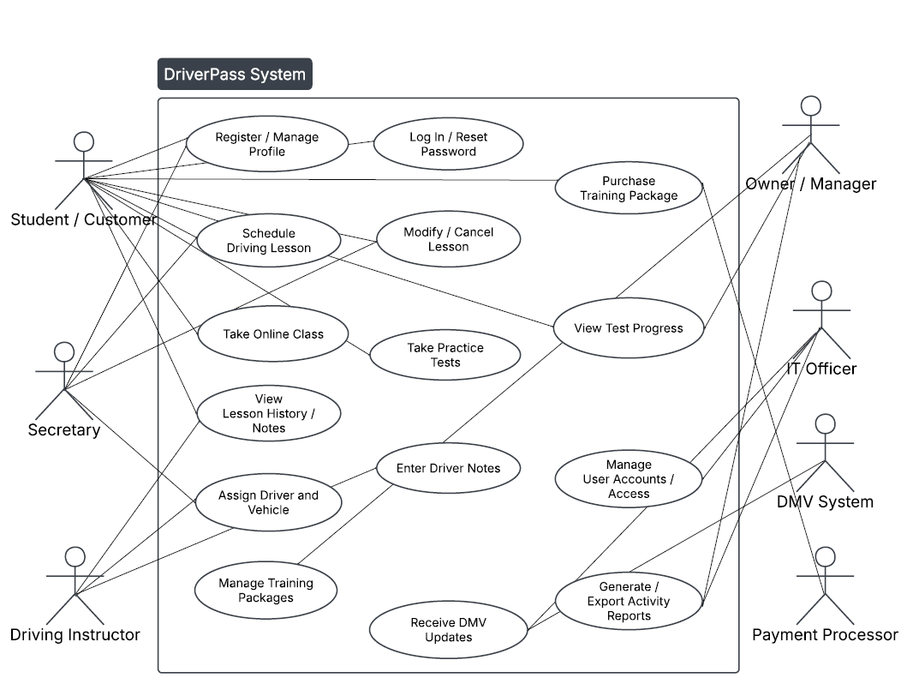

UML Activity Diagrams
Purchase a Training Package
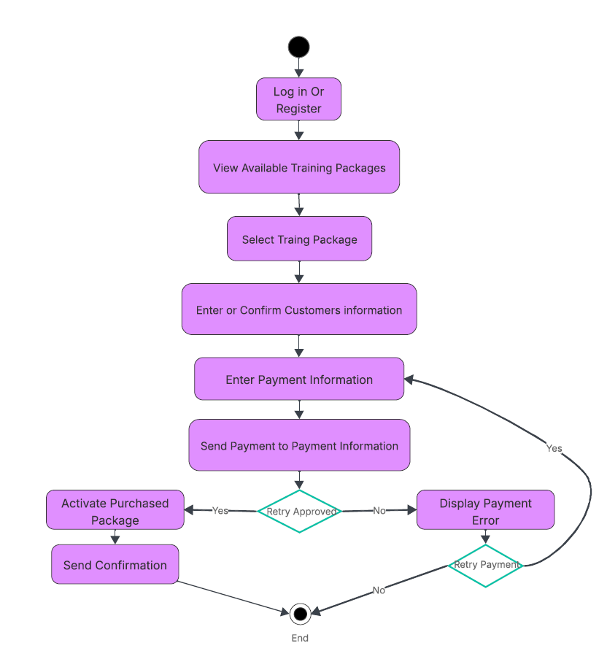

Schedule a Driving Lesson
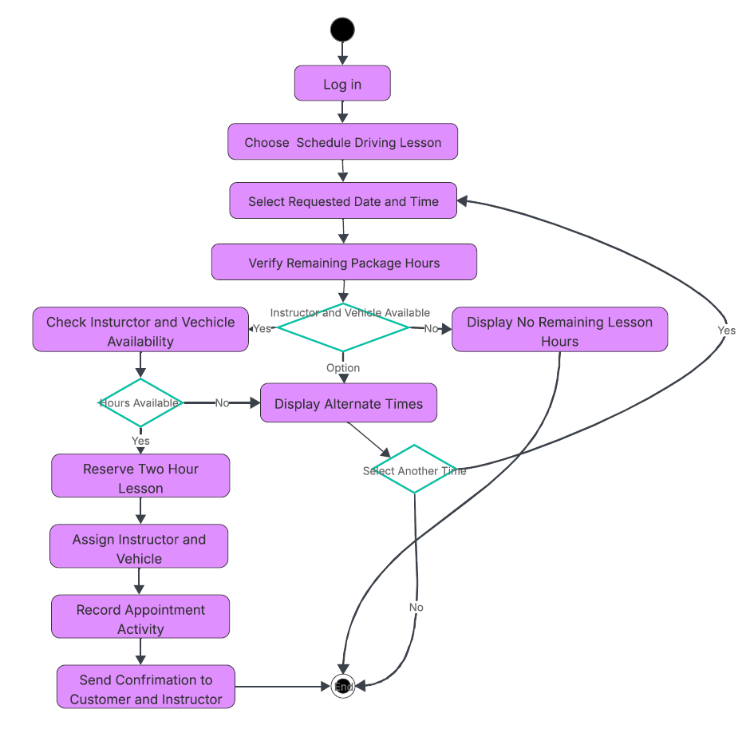

UML Sequence Diagram
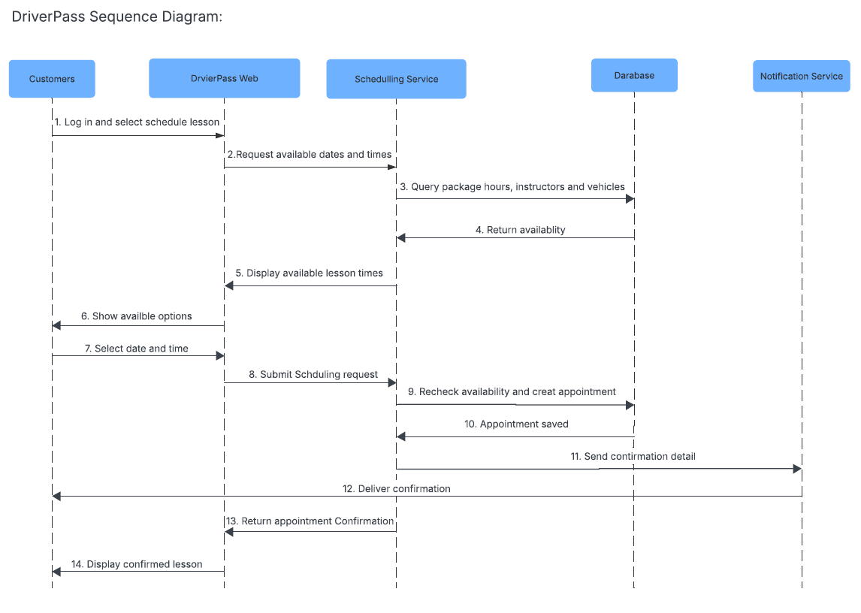

UML Class Diagram
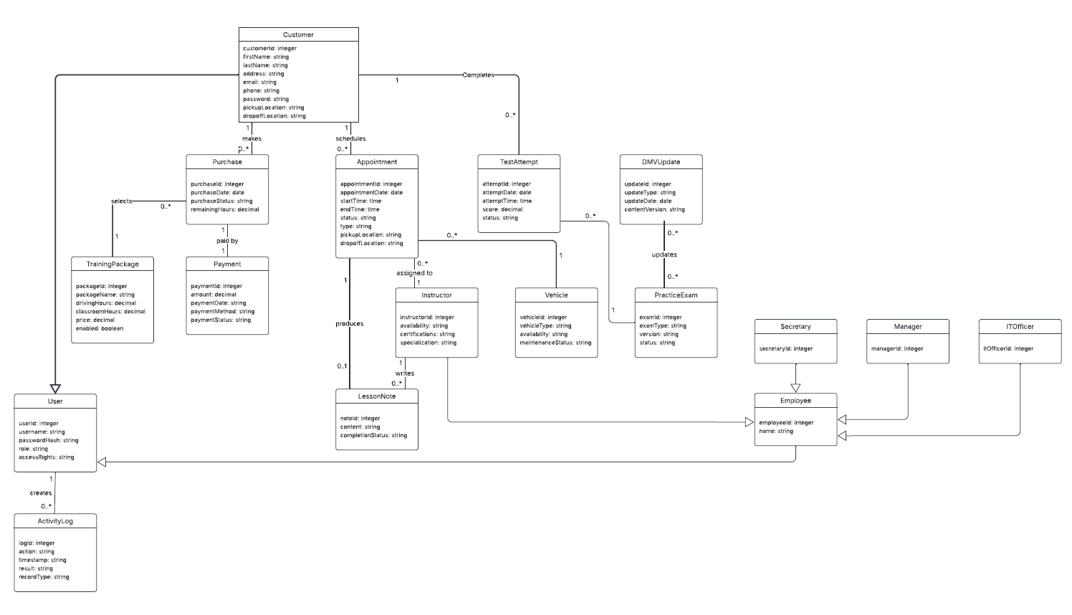

Technical Requirements

Hardware and User Devices
• The DriverPass system will be hosted in a cloud environment and accessed through desktop computers, laptops, tablets, and smartphones with a reliable internet connection.
• DriverPass office employees should have computers capable of running a current web browser and exporting reports to Microsoft Excel.
• Cloud servers must provide sufficient processing, storage, redundancy, and automatic backups for customer records, appointments, test results, reports, and audit logs.

Software and Application Platform
• The system will be a responsive web application that supports current versions of major browsers on Windows, macOS, Linux, Android, and iOS.
• The application should use a layered architecture consisting of a user interface, business logic layer, data-access layer, and secure relational database.
• The system must integrate with an external payment processor for package purchases and with the DMV source used to receive updated rules, policies, and practice questions.
• Reports must be viewable in the system and downloadable in a format compatible with Microsoft Excel.

Database and Data Management
• A relational database will store users, customer profiles, employee roles, packages, purchases, payment transaction references, appointments, instructor schedules, vehicle availability, lesson notes, practice exams, test attempts, DMV updates, and activity logs.
• Database rules must prevent scheduling conflicts involving the same instructor or vehicle and must preserve a record of who created, modified, or canceled each appointment.
• Regular automated backups, recovery testing, and data-retention procedures are required to protect business and customer information.

Security
• All connections must use HTTPS encryption, and passwords must be stored using secure password hashing rather than plain text.
• Role-based access control must limit customers, secretaries, instructors, managers, and IT administrators to the information and functions required for their responsibilities.
• Accounts should lock after repeated failed login attempts, while secure password-reset features must be available for customers and employees.
• Complete credit card information should not be permanently stored by DriverPass. The payment provider should return a secure transaction token or reference number.
• Administrative actions, appointment changes, login failures, and system errors must be logged and available for reporting.

Performance, Availability, and Maintenance
• The system should be available 24 hours a day, with pages, schedules, and test results loading within a few seconds under normal operating conditions.
• Cloud monitoring should notify the IT officer of service failures, unauthorized access attempts, integration problems, or other system errors.
• The design must allow packages to be enabled or disabled and should support future additions to training packages, online content, and practice exams with limited changes to existing components.
• Testing tools should support unit, integration, security, usability, and browser-compatibility testing before deployment.

